**DAILY ONLINE ACTIVITIES SUMMARY**

|  |  |  |  |  |  |  |  |  |
| --- | --- | --- | --- | --- | --- | --- | --- | --- |
| **Date:** | **20/06/2020** | | | | | **Name:** | **SUJANA** | |
| **Sem & Sec** | **IV sem & B section** | | | | | **USN:** | **4AL18CS089** | |
| **Online Test Summary** | | | | | | | | |
| **Subject** | | **Data Communication** | | | | | | |
| **Max. Marks** | | **30** | | **Score** | | | **24** | |
| **Certification Course Summary** | | | | | | | | |
| **Course** | **Blockchain Basics** | | | | | | | |
| **Certificate Provider** | | | **Greatlearning academy** | | **Duration** | | | **2.5hours** |
| **Coding Challenges** | | | | | | | | |
| **Problem Statement1:** Write a Java program to count number of bits to be flipped to convert A to B.  **Problem Statement2:**  Program that compares counting words in files using an ArrayList and a Map.  **Problem Statement3:** Write a C Program to rotate an array by K positions. | | | | | | | | |
| **Status: Executed** | | | | | | | | |
| **Uploaded the report in Github** | | | | | **YES** | | | |
| **If yes Repository name** | | | | | **Online-coding** | | | |
| **Uploaded the report in slack** | | | | | **YES** | | | |

Online Test Summary: 18CS46 test was scheduled from 2:00pm t0 2:30pm .The portion for the IA was 3rd and 4th module there were 30 questions and the time assigned was 30 minutes the questions were mcq type.

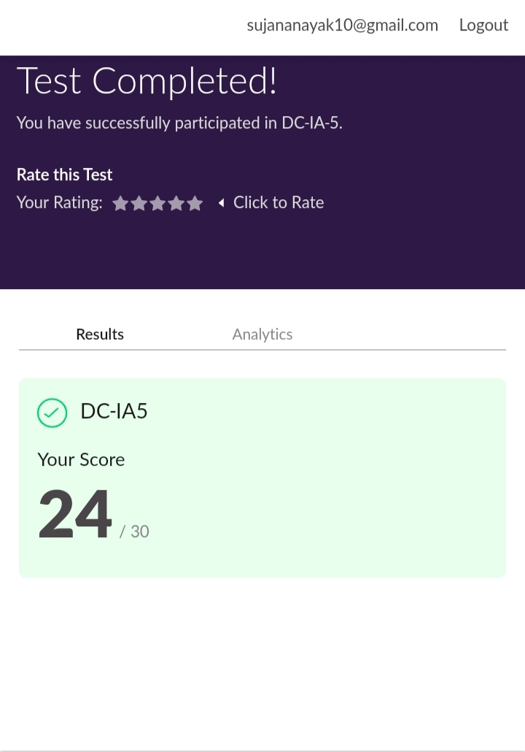

This is the snap shot of completion of test and the marks obtained in 18CS46.

Online Certification Course Summary: Today I have registered for the new Certification course that is Blockchain Basics and today I have learnt about database system in blockchain and their characteristics.

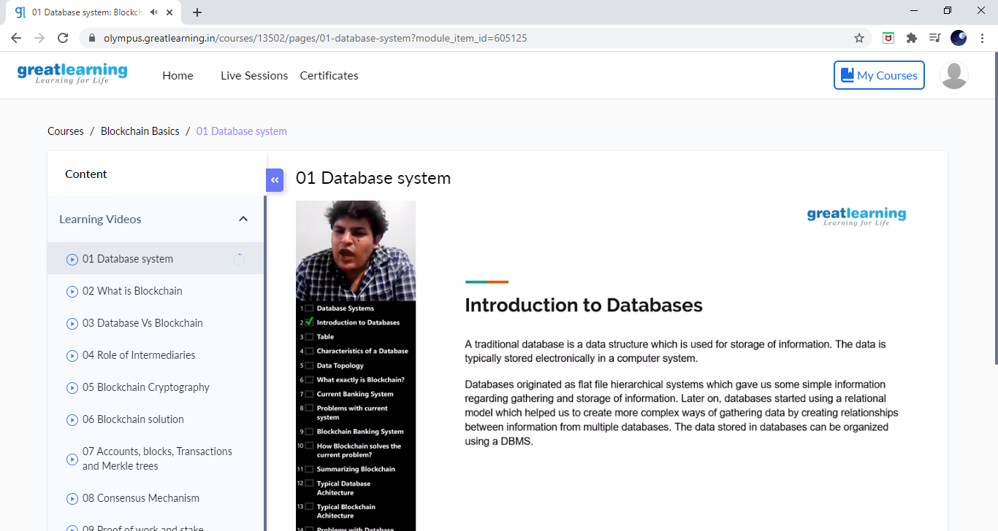

This is the Snap Shot of today’s session.

Online Coding Summary: **Today I had received one program from prof. Shilpa CSE Dept. the other from Prof.Vasudev CSE Dept. and Prof.Venkatesh CSE Dept. The program is mentioned above in the coding challenges(pg.01). I have also uploaded it to my Github repository.**

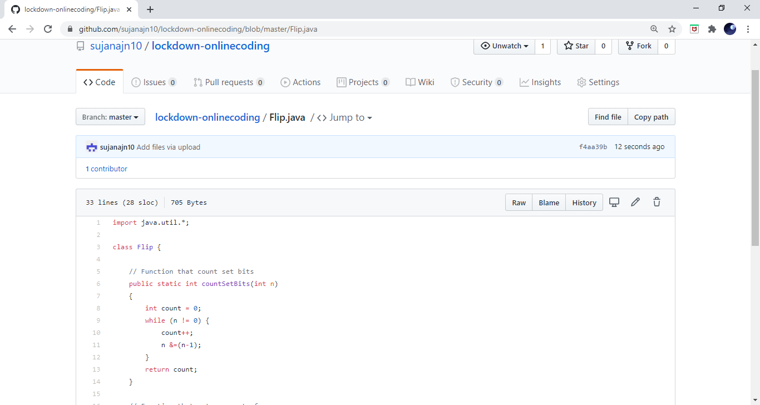

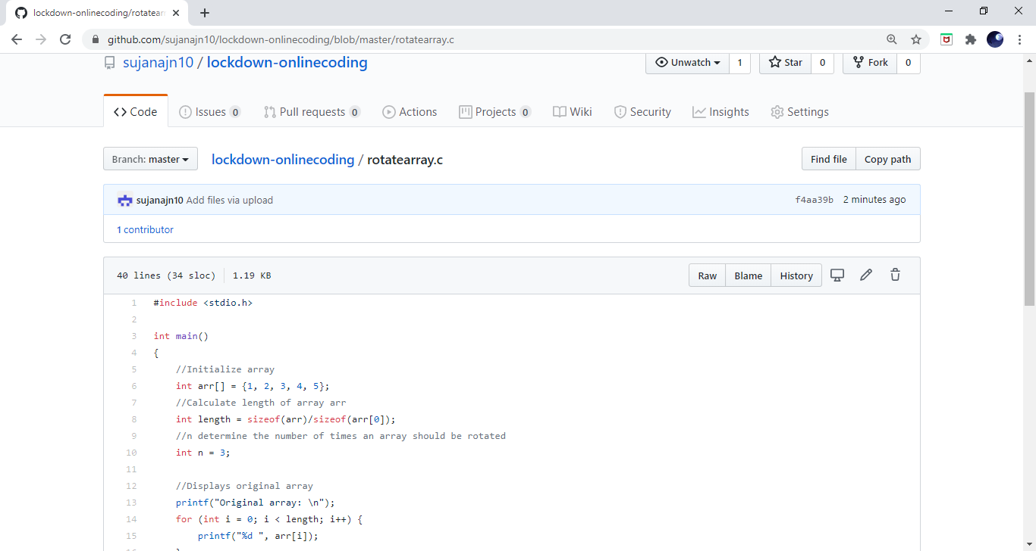

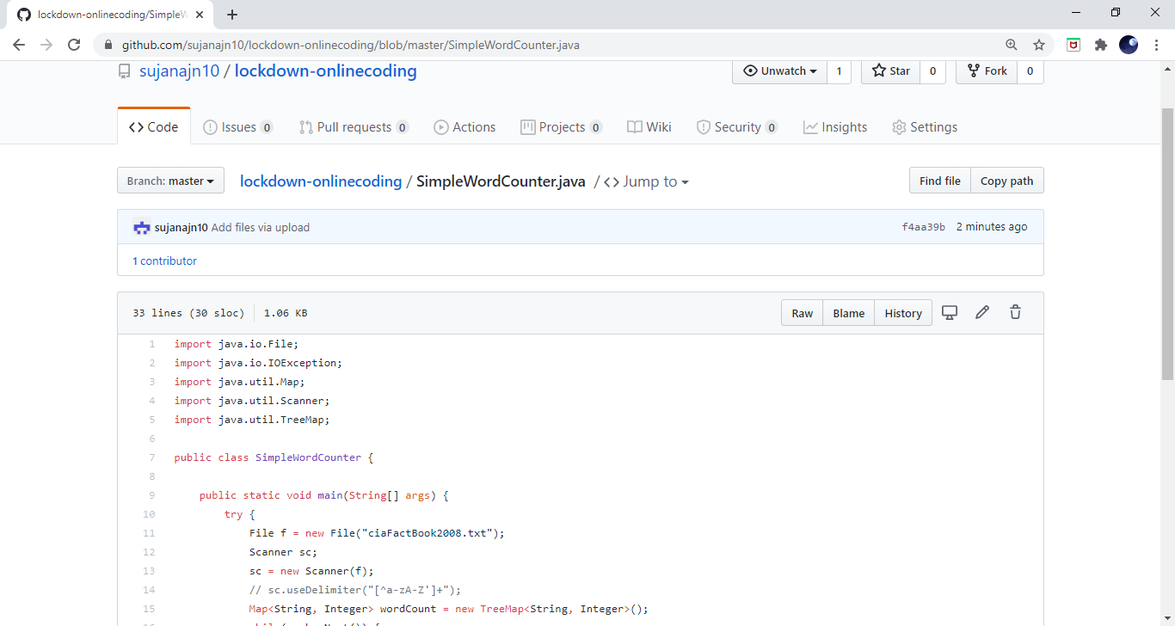

**This is the snap shot of my Github repository** were I have uploaded the code. File name is Flip.java, SimpleWordCounter.java and rotatearray.c